Task-Based Activity: Understanding your role as a Canadian citizen
Laubach Connection: Laubach Way to Reading (LWR) Book 3, Lesson 22
OALCF Link
Relevant Goal Paths
Apprenticeship, Employment, Independence, Postsecondary, Secondary School Credit
Rationale: Learners on all of the goal paths will need to read information from the Internet for a variety of different reasons. In addition, most learners are Canadian citizens and should understand their role and responsibilities.

Task-Based Activity Description: The learner will read a brief text (excerpt from Internet website) to locate and connect information about the role and responsibilities of a Canadian citizen.
Competency, Task Group and Level Indicators
(See Assessment page for performance descriptors)
A: Find and Use Information
A1: Read continuous text
- A1.2: Read text to locate and connect ideas and information

Materials Required
- Pen or pencil and eraser
- Question sheets

Overview
Activity Introduction
This task uses an excerpt from a government website where you can learn about citizenship in Canada.

Lesson twenty-two is about a family from Cuba who become U.S. citizens. Discuss with the learner if they know anyone who has ever had to go through the process of becoming a Canadian citizen. Discuss the fact that in Canada there are responsibilities associated with being or becoming a Canadian citizen and it is important to know what these responsibilities are.

New words
Determine any new words that you think are being introduced in the activity and review those words with the learner. Suggested words: principles, individuals, arbitrary, prosperity, territorial, impartial, citizen.

Instructions
- Have the learner fill in their name and the date.
- Have the learner complete the pre self-assessment.
- Have the learner complete the task-based activity.
- After completing the activity have the learner complete the post self-assessment.
- After the learner has completed the task-based activity complete the assessment section and review the results with the learner.

Extension activities
- Have a group discussion about your role as a Canadian citizen
- Research and discuss basic human rights

Task-Based Activity: Understanding your role as a Canadian citizen

Learner Name: ___________________________ Date: ____________________________

Pre self-assessment

I need to improve my skills at reading texts:
- Yes
- No

Activity

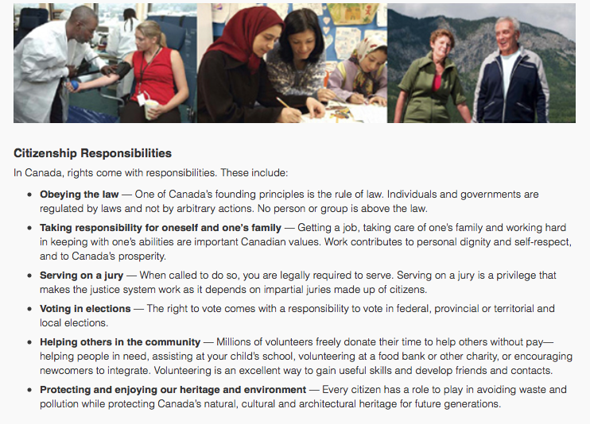
Source: http://www.cic.gc.ca/english/resources/publications/discover/section-04.asp

- As a Canadian citizen what are three things you have a responsibility to do?

- ________________________________________________________________________
- ________________________________________________________________________
- ________________________________________________________________________
- What types of elections are you responsible to vote in, as a Canadian citizen?
___________________________________________________________________________
___________________________________________________________________________
- Underline, highlight or circle what your role is with respect to protecting and enjoying our environment?

Post self-assessment

I think my skills have improved as a result of completing this activity.
- Yes
- No

Learner comments:
______________________________________________________________________________
______________________________________________________________________________
______________________________________________________________________________

Assessment
Task-Based Activity: Understanding your role as a Canadian citizen
Learner Name: __________________________ Date: ____________________________

Practitioner Name: _______________________________________

Performance Descriptors | Needs Work | Improving | Excellent
A1.2: Read texts to locate and connect ideas and information
- scans text to locate information
- locates multiple pieces of information in simple texts
- makes low-level inferences
- makes connections between sentences and between paragraphs in a single text
- reads more complex texts to locate a single piece of information
- follows the main events of descriptive, narrative and informational texts
- obtains information from detailed reading
- begins to identify sources and evaluate information
The learner needs to work on the following:

This task was successfully completed ______ This task needs to be tried again ______

Practitioner Comments:

Learner Comments:

